YEAR 11 Mathematics Extension 1 – 2005 Yearly Examination (Term 4)

Question 1. Marks

(a) An arc of length 10 cm subtends an angle of θ radians at the centre of a 2
circle of radius 5 cm.
Find the value of θ correct to the nearest minute.

(b) Find the equation of the curve passing through the point 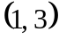 with a 3
gradient function of 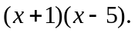

- Find the primitive function of

(i) 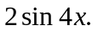 2
(ii) 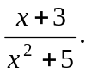 3

Question 2. [START A NEW PAGE]

(a) The point A lies on the line 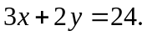 A line, perpendicular to the x-axis, is
drawn through point A and meets the x-axis at B.

(i) If B is 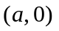, find the coordinates of A in terms of a. 1

- The triangle bounded by the lines AB, 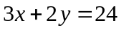 and the x-axis has
an area of 27 square units, find the coordinates of A. 3

(b) (i) Given that A is 1
Find the coordinates of C if ABCD is a rhombus.

(ii) Hence, find the area of ABCD. 3

(c) Find the integral of 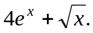 2

Question 3. [START A NEW PAGE]

(a) (i) Express 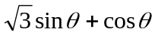 in the form 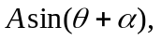 2
where A > 0 and 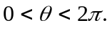

(ii) Find the minimum value of and 2
determine when this minimum first occurs for 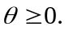

(iii) Neatly sketch 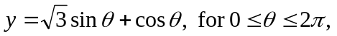 clearly showing 3
showing all important feature.

(b) Using the t-results, solve 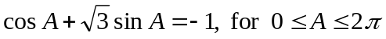 3

Question 4. [START A NEW PAGE] Marks

(a) Find the exact area bounded by 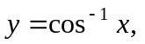 the x-axis and 3
the lines at 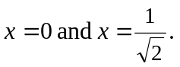

(b) Prove that 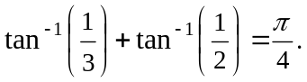 3

(c) Find 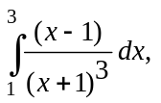 using the substitution 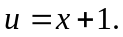 4

Question 5. [START A NEW PAGE]

(a) If 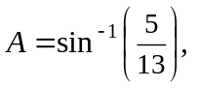 find the value of 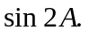 2

(b) Given 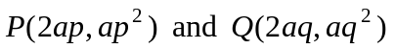 are two points on the parabola 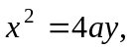 4
and 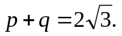
Find the angle between the chord PQ and the axis of the parabola.

(c) P is a point on 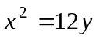 and O is the Origin. Q is the foot of the perpendicular 4
from the focus, S, of the parabola to OP.
Show that the locus of Q is given by 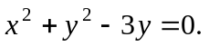

Question 6. [START A NEW PAGE]

- Find the inverse function of 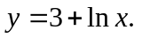 1

- Differentiate 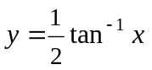 with respect to x. 1

- Neatly sketch and its derivative. 3

- Find the domain and range of 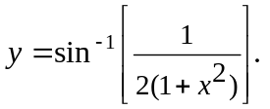 3

- Neatly sketch 2

THE END

